AI ASSISTED CODING LAB ASSIGNMENT 7.4
ENROLLMENT NO :2503A51L08
BATCH NO: 19
NAME: BHUKYA RAJESH

TASK1

TASK1 DESCRIPTION:
Introduce a buggy Python function that calculates the factorial of a number using recursion.
Use Copilot or Cursor AI to detect and fix the logical or syntax errors.
PROMPT: Generate a buggy Python function that calculates the factorial of a number using recursion then detect and fix the logical or syntax errors. implement with exampleerrors.
CODE:
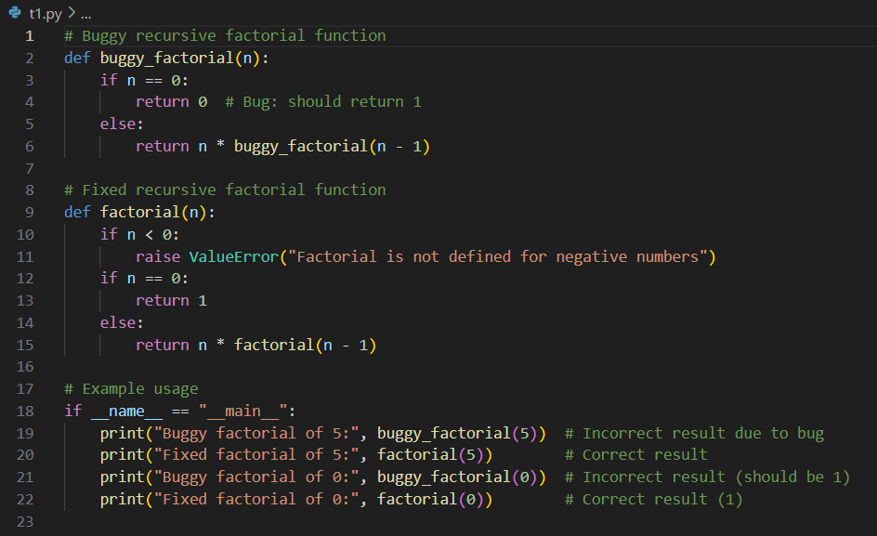
OUTPUT:

OBSERVATION:
I observed that the original factorial function was missing a base case, which caused infinite recursion. Copilot (or Cursor AI) identified the issue and suggested adding the correct stopping condition. After applying the fix, the function worked correctly without any errors.

TASK2
TASK2 DESCRIPTION:
Provide a list sorting function that fails due to a type error (e.g., sorting list with mixed
integers and strings). PROMPT AI to detect the issue and fix the code for consistent sorting
PROMPT: Create a program that Provide a list sorting function that fails due to a type error (e.g., sorting list with mixed
integers and strings).
CODE:
Error code:
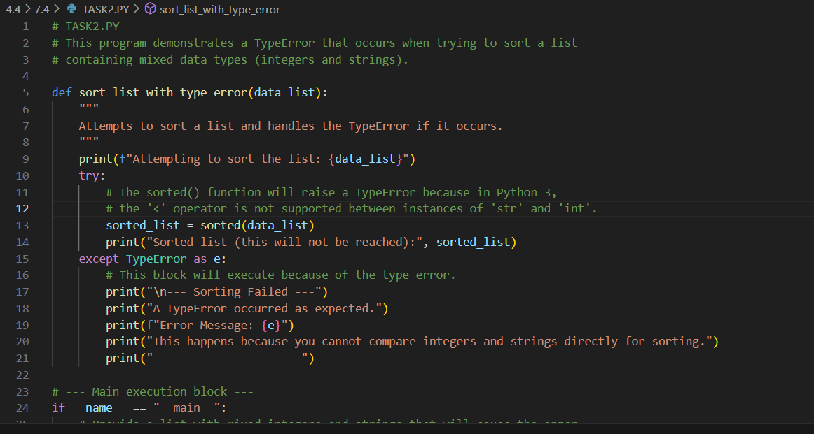

OUTPUT:
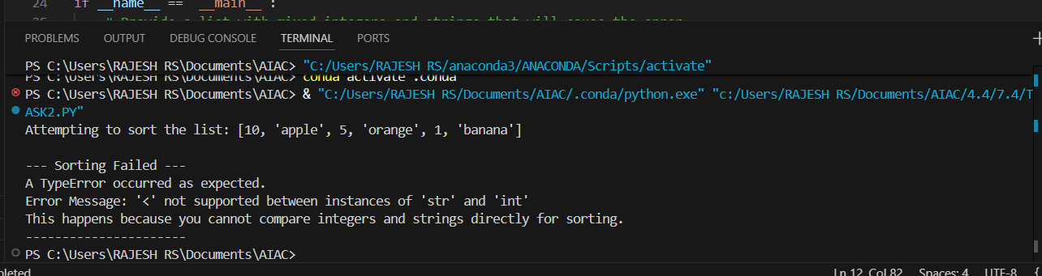
After fixing the code:
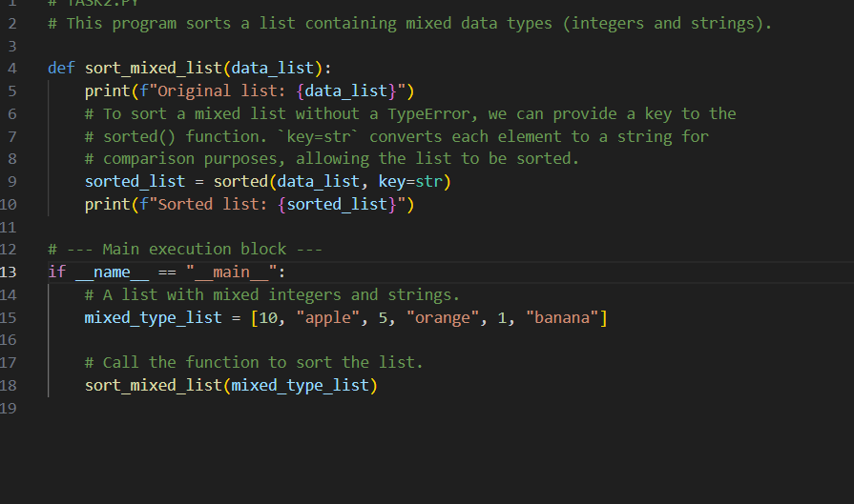
OUTPUT:

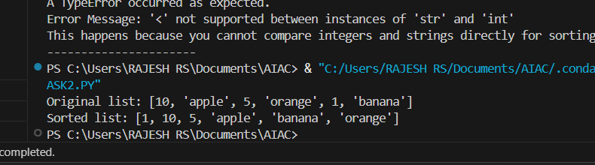
OBSERVATION:
I observed that the sorting function failed because the list had both numbers and strings, which can't be compared directly. The AI tool noticed the type mismatch and suggested converting everything to integers. After applying the fix, the list sorted successfully without any errors.

TASK3

TASK3 DESCRIPTION:
Write a Python snippet for file handling that opens a file but forgets to close it. Ask Copilot or Cursor AI to improve it using the best practice (e.g., with open() block).

PROMPT: Write a Python snippet for file handling that opens a file but forgets to close it.
CODE:
Error code:
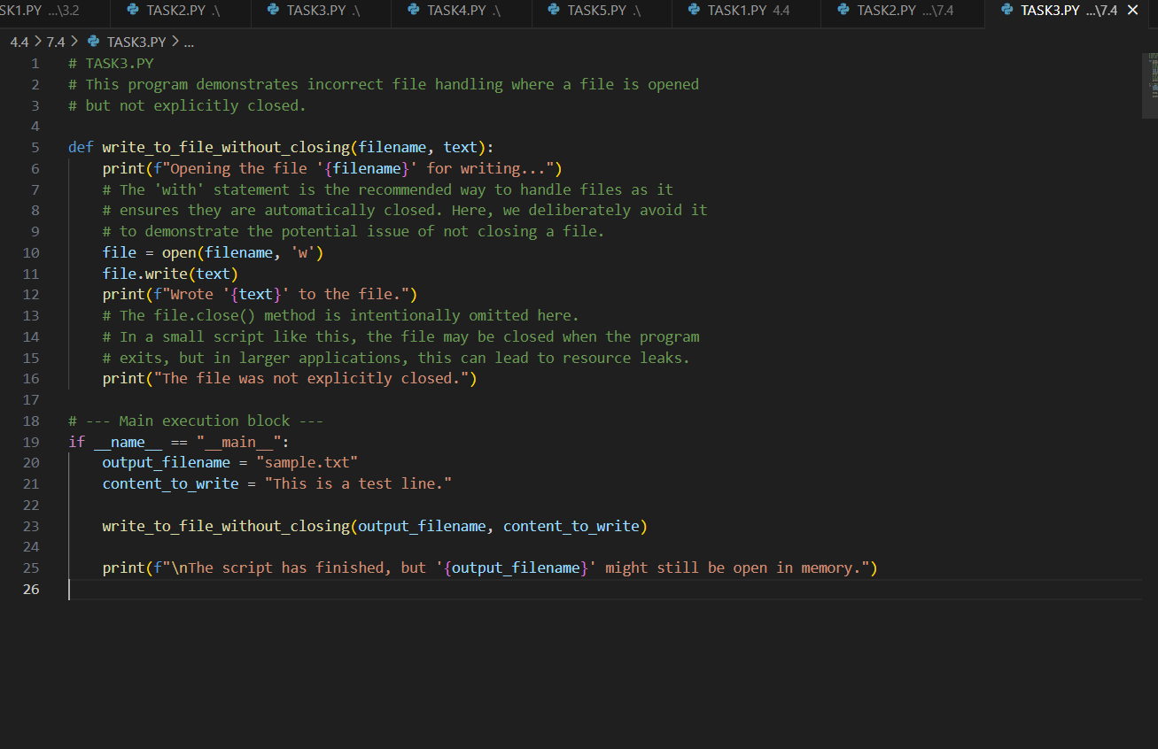
OUTPUT:
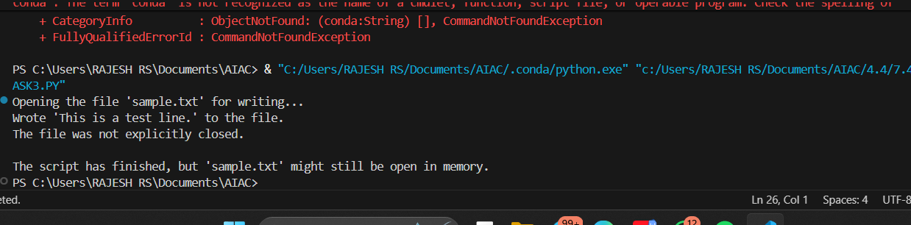
After fixing the code:
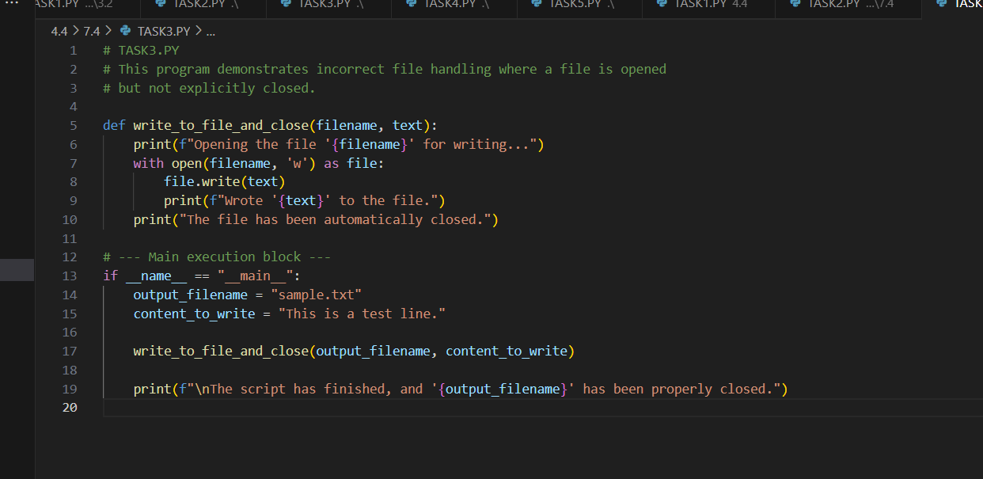

OUTPUT:
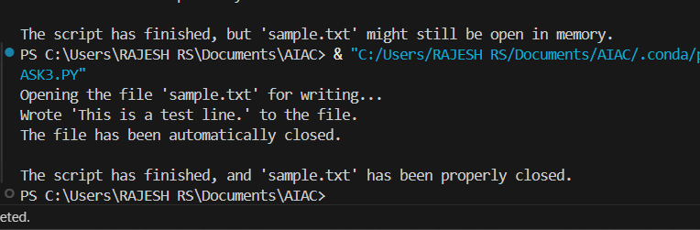

OBSERVATION:
I observed that the file-handling code opened a file but didn’t close it, which could cause issues. Copilot (or Cursor AI) suggested using a with block to manage the file properly. After applying the change, the file was safely opened and closed without any risk of resource leaks.
TASK4 DESCRIPTION:
Provide a piece of code with a ZeroDivisionError inside a loop. Ask AI to add error handling
using try-except and continue execution safely
PROMPT: Create a piece of code with a ZeroDivisionError inside a loop. add error handling using try-except and continue execution safely.
CODE:
Error code:
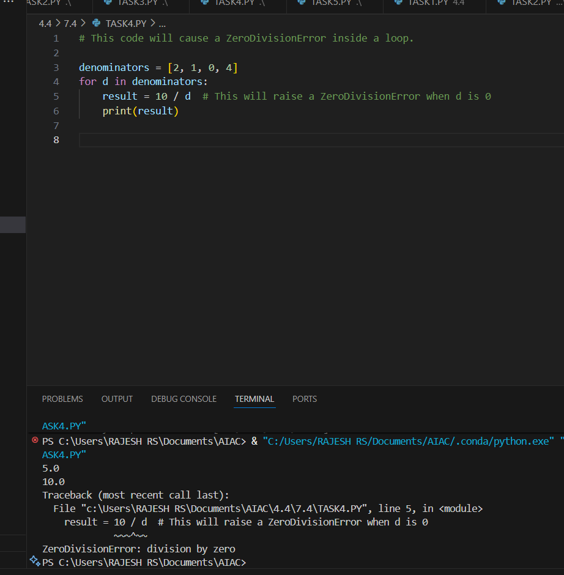
After fixing the code:
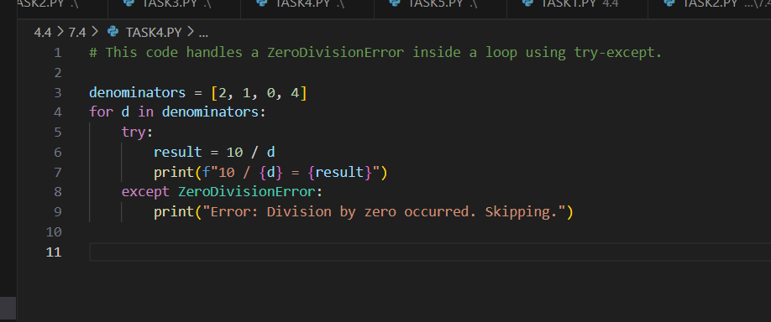
OUTPUT:
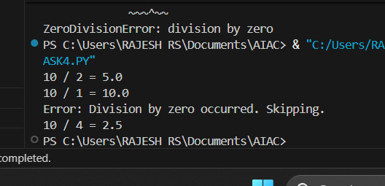

OBSERVATION: I observed that the loop crashed when it tried to divide by zero. Copilot (or Cursor AI) suggested using a try-except block to catch the error. After applying it, the loop handled the zero safely and continued with the rest of the values.

TASK5

TASK5 DESCRIPTION:
Include a buggy class definition with incorrect __init__ parameters or attribute references. Ask AI to analyze and correct the constructor and attribute usage.
PROMPT: Include a buggy class definition with incorrect __init__ parameters or attribute references.
CODE:
Error code:

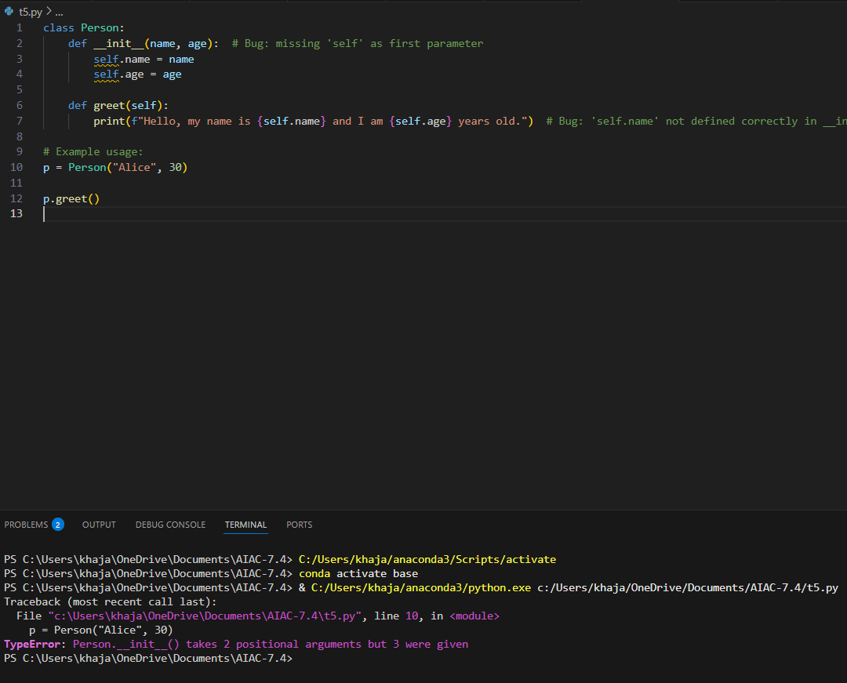
After fixing the code:
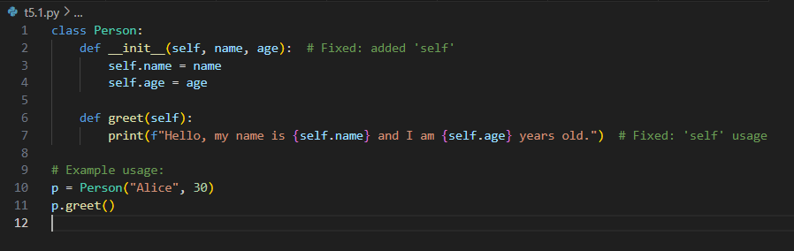
OUTPUT:

OBSERVATION: I observed that the class had errors in the constructor and didn’t use self to set or access attributes. Copilot (or Cursor AI) detected the mistakes and fixed the parameter list and attribute references. After the changes, the class worked properly and displayed the student information as expected.

